**Array:**

**An array is defined as the collection of similar type of data items stored at contiguous memory locations.** Arrays are the derived data type in C programming language which can store the primitive type of data such as int, char, double, float, etc.

Arrays a kind of data structure that can store a fixed-size sequential collection of elements of the same type. An array is used to store a collection of data, but it is often more useful to think of an array as a collection of variables of the same type.

Instead of declaring individual variables, such as number0, number1, ..., and number99, you declare one array variable such as numbers and use numbers[0], numbers[1], and ..., numbers[99] to represent individual variables. A specific element in an array is accessed by an index.

All arrays consist of contiguous memory locations. The lowest address corresponds to the first element and the highest address to the last element.

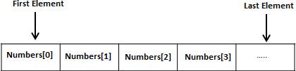

**Declaring Arrays**

To declare an array in C, a programmer specifies the type of the elements and the number of elements required by an array as follows −

**type arrayName [ arraySize ];**

This is called a *single-dimensional* array. The **arraySize** must be an integer constant greater than zero and **type** can be any valid C data type. For example, to declare a 10-element array called **balance** of type double, use this statement −

**double balance[10];**

Here *balance* is a variable array which is sufficient to hold up to 10 double numbers.

Initializing Arrays

You can initialize an array in C either one by one or using a single statement as follows −

double balance[5] = {1000.0, 2.0, 3.4, 7.0, 50.0};